CA3203: Internet of Things

Project Title: IoT-Based Dual Authentication Entry System Using RFID and Image Processing

Team Members: Sathya Balan K, Anbarasu R, Jeyavarma R, Srinithish B
Department: Information Science and Technology, CEG
Date: 23rd April 2025

Abstract
This project aims to develop a smart access control system that ensures secure entry using a dual-layer authentication mechanism — RFID-based card scanning and camera-based facial recognition. The goal is to enhance physical security by verifying both the RFID card and the identity of the cardholder before granting access. By integrating an ESP32-CAM module, an RFID reader (RC522), a servo motor, indicator lights, and a local machine for image processing, the system enforces stringent entry validation, making unauthorized access highly improbable.

🔹 2. Introduction
Traditional RFID-based access control systems are vulnerable to card cloning or misuse if the card falls into the wrong hands. To address this, the proposed system introduces an additional facial recognition step after RFID verification. Only when both the card and the facial identity match, access is granted.
The ESP32-CAM module, in conjunction with a local computer, handles real-time authentication and controls door mechanisms through a servo motor, offering enhanced security at minimal cost.

3. Objectives
- Implement dual authentication for secured entry.
- Verify both RFID card and user identity through face recognition.
- Provide immediate feedback on authentication status using LEDs.
- Improve traditional RFID systems by adding an IoT-enabled smart layer.

🔹 4. Components Required
Component | Specification | Quantity
ESP32-CAM Development Board | Wi-Fi & Bluetooth MCU | 1
Arduino UNO | Micro Controller | 1
RFID Reader(RC522) | 13.56 MHz RFID reader module | 1
RFID Tags/Cards | MIFARE Classic cards | As needed
Servo Motor | SG90 or equivalent | 1
LEDs (Red & Green) | Status indication | 2
Resistors, Wires | Various | As needed
Local Computer | Image processing using Deepface | 1

🔹 5. Circuit : 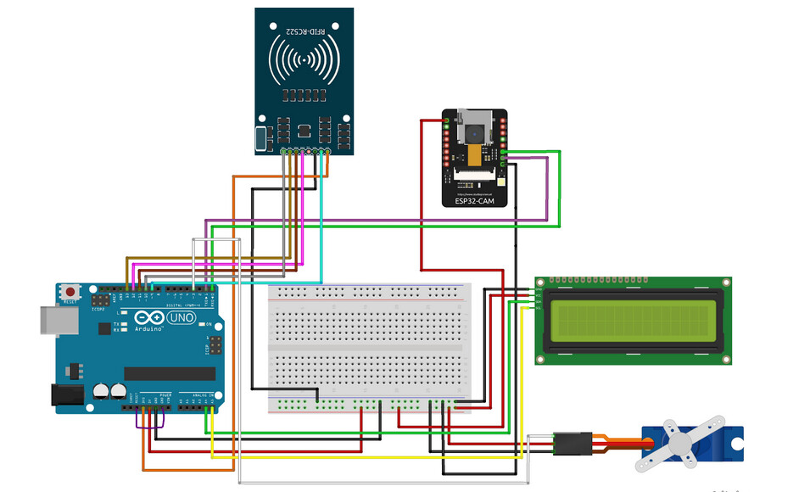

🔹 6. Working Principle
- RFID Reader: Detects the RFID card and checks UID against an authorized database.
- ESP32-CAM: Captures the user's photo after successful card detection.
- Local Machine: Receives the image and matches it with the stored face profile linked to the UID.
- Servo Motor: Unlocks the door upon successful dual verification.
- LED Indicators:
    - Green LED: Access Granted
    - Red LED: Access Denied

🔹 7. Flowchart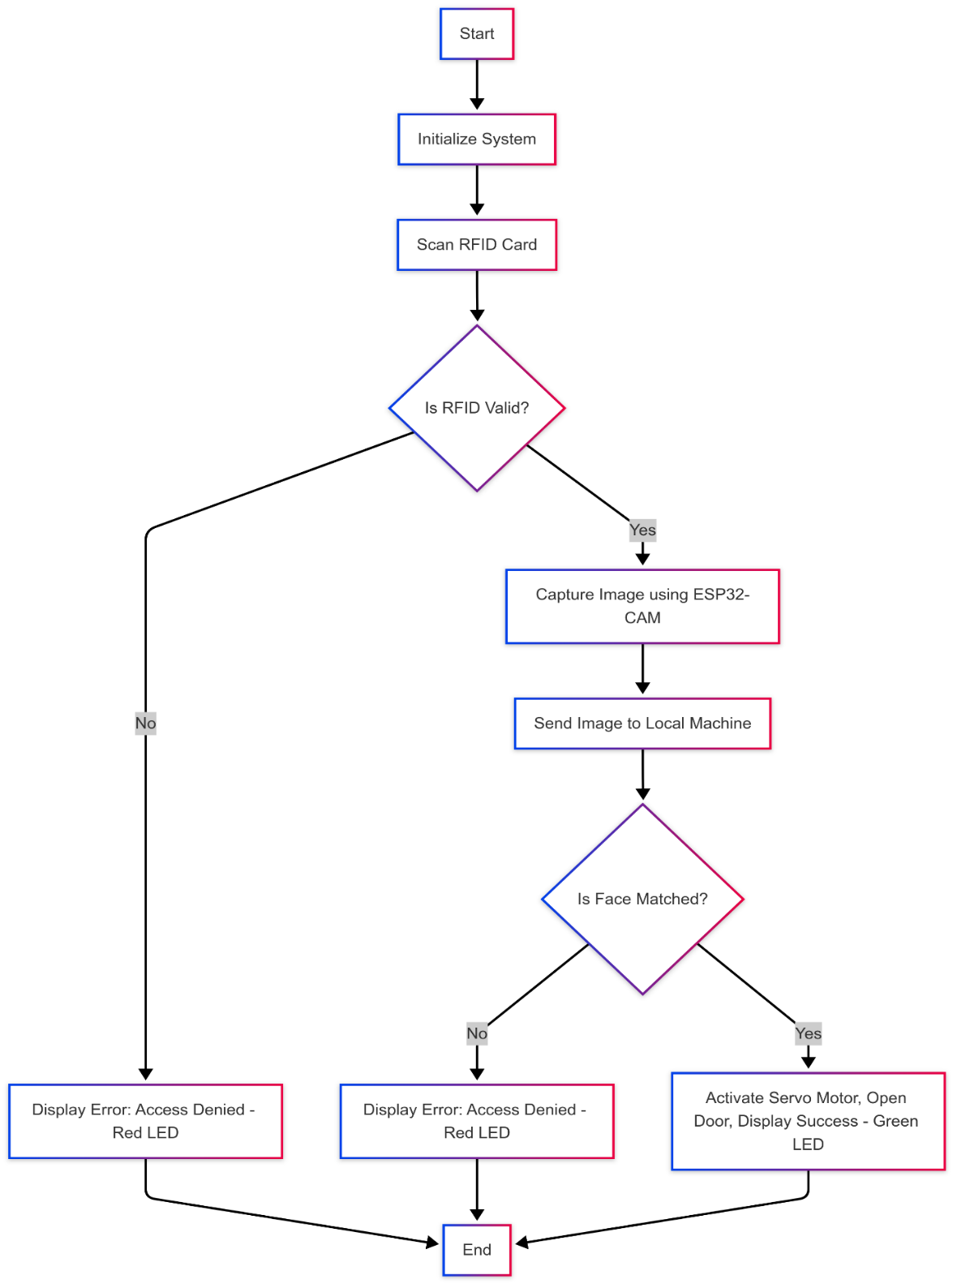

🔹 8. Software Used
• Arduino IDE: For programming ESP32-CAM.
• Deepface (Python): For face detection and recognition.
• Serial Monitor: For debugging and logs.

🔹 9. Code Explanation
- ESP32-CAM:
- Initializes RFID reader and camera.
- Reads RFID UID using SPI interface.
- Captures an image upon valid UID.
- Sends captured image to local machine via HTTP or Wi-Fi.
- Local Machine:
- Receives image and processes using Deepface.
- Compares with stored face profiles.
- Sends "grant" or "deny" signal back to ESP32-CAM.
- Servo Motor and LEDs:
- Servo rotates to unlock door on "grant".
- LEDs indicate system status.
.

🔹 10. Results and Observations
Scenario | RFID UID Status | Face Match Status | Result
Invalid RFID | - | - | Access Denied (Red LED)
Valid RFID, Face mismatch | Valid | No Match | Access Denied (Red LED)
Valid RFID, Face match | Valid | Match | Access Granted (Green LED, Servo Rotates)

🔹 11. Advantages
• Enhanced security with two-factor authentication.
• Low-cost, scalable hardware setup.
• Reduces chances of unauthorized entry even if RFID is compromised.
• Real-time, fast decision-making system.

🔹 12. Limitations
• Requires stable Wi-Fi or local network for quick image transfer.
• Processing load handled by a local machine — not completely edge-computing.
• Face recognition accuracy depends on lighting and camera quality.

13. Future Scope
- Implement cloud-based face recognition using platforms like AWS Rekognition.

- Add automatic attendance marking systems.

- Include liveness detection (to prevent photo spoofing).

- Solar/battery backup for continuous operation

🔹 14. Conclusion
The IoT-Based Dual Authentication Entry System effectively combines RFID technology with facial recognition to offer a highly secure access control solution. Leveraging affordable components like ESP32-CAM and local processing via Deepface, the project demonstrates a practical application of IoT in real-world security systems. Future improvements can make it even more robust and autonomous.

15. Appendix A: Source Code
#include <esp_camera.h>
#include <SPI.h>
#include <MFRC522.h>
#include "FS.h"
#include "SPIFFS.h"
#include <WiFi.h>
#include <HTTPClient.h>

// // RFID Pins
// #define RST_PIN 15
// #define SDA_PIN 14
// MFRC522 rfid(SDA_PIN, RST_PIN);

// Camera pins (for OV2640)
#define PWDN_GPIO_NUM 32
#define RESET_GPIO_NUM -1
#define XCLK_GPIO_NUM 0
#define SIOD_GPIO_NUM 26
#define SIOC_GPIO_NUM 27
#define Y9_GPIO_NUM 35
#define Y8_GPIO_NUM 34
#define Y7_GPIO_NUM 39
#define Y6_GPIO_NUM 36
#define Y5_GPIO_NUM 21
#define Y4_GPIO_NUM 19
#define Y3_GPIO_NUM 18
#define Y2_GPIO_NUM 5
#define VSYNC_GPIO_NUM 25
#define HREF_GPIO_NUM 23
#define PCLK_GPIO_NUM 22

// Signal from UNO
#define SIGNAL_FROM_UNO 12
#define SIGNAL_TO_UNO_VALID 13
#define SIGNAL_TO_UNO_INVALID 14

// LED Flash pin
#define FLASH_LED_PIN 4 // onboard flash LED (GPIO 4)

// WiFi credentials
const char* ssid = "BATMAN";
const char* password = "12345678";

// Server URL
String serverURL = "http://10.16.52.207:5000/upload"; // <<< your server IP

void setup() {
Serial.begin(115200);

// Init Flash LED
pinMode(FLASH_LED_PIN, OUTPUT);
digitalWrite(FLASH_LED_PIN, LOW);

// UNO Signals
pinMode(SIGNAL_TO_UNO_VALID, OUTPUT);
pinMode(SIGNAL_TO_UNO_INVALID, OUTPUT);
pinMode(SIGNAL_FROM_UNO, INPUT); // Corrected to INPUT
digitalWrite(SIGNAL_TO_UNO_VALID, LOW);
digitalWrite(SIGNAL_TO_UNO_INVALID, LOW);

// // Init RFID
// SPI.begin(12, 2, 13, 14); // SCK=12, MISO=2, MOSI=13, SS=14
// rfid.PCD_Init();
// Serial.println("RFID Reader Initialized");

// Init SPIFFS
if (!SPIFFS.begin(true)) {
Serial.println("SPIFFS Mount Failed");
while (true) delay(1000);
}
Serial.println("SPIFFS Mounted");

// Init Camera
camera_config_t config;
config.ledc_channel = LEDC_CHANNEL_0;
config.ledc_timer = LEDC_TIMER_0;
config.pin_d0 = Y2_GPIO_NUM;
config.pin_d1 = Y3_GPIO_NUM;
config.pin_d2 = Y4_GPIO_NUM;
config.pin_d3 = Y5_GPIO_NUM;
config.pin_d4 = Y6_GPIO_NUM;
config.pin_d5 = Y7_GPIO_NUM;
config.pin_d6 = Y8_GPIO_NUM;
config.pin_d7 = Y9_GPIO_NUM;
config.pin_xclk = XCLK_GPIO_NUM;
config.pin_pclk = PCLK_GPIO_NUM;
config.pin_vsync = VSYNC_GPIO_NUM;
config.pin_href = HREF_GPIO_NUM;
config.pin_sccb_sda = SIOD_GPIO_NUM;
config.pin_sccb_scl = SIOC_GPIO_NUM;
config.pin_pwdn = PWDN_GPIO_NUM;
config.pin_reset = RESET_GPIO_NUM;
config.xclk_freq_hz = 20000000;
config.pixel_format = PIXFORMAT_JPEG;
config.frame_size = FRAMESIZE_QVGA;
config.jpeg_quality = 10;
config.fb_count = 1;

if (esp_camera_init(&config) != ESP_OK) {
Serial.println("Camera Init Failed");
while (true) delay(1000);
}
Serial.println("Camera Initialized");

// Init WiFi
WiFi.begin(ssid, password);
Serial.print("Connecting to WiFi..");
while (WiFi.status() != WL_CONNECTED) {
delay(500);
Serial.print(".");
}
Serial.println("\nWiFi Connected!");
Serial.print("ESP32 IP Address: ");
Serial.println(WiFi.localIP());
}

void loop() {
if (digitalRead(SIGNAL_FROM_UNO) == HIGH) {
delay(50); // 🔥 small debounce delay (optional but improves stability)

Serial.println("✅ Valid RFID Detected!");

// Turn ON Flash
digitalWrite(FLASH_LED_PIN, HIGH);
delay(200); // small delay for LED stabilization

// Capture Image
camera_fb_t * fb = esp_camera_fb_get();
if (!fb) {
Serial.println("Camera capture failed");
digitalWrite(FLASH_LED_PIN, LOW);
return;
}

// Send Image to Server
if (WiFi.status() == WL_CONNECTED) {
HTTPClient http;
http.begin(serverURL);
http.addHeader("Content-Type", "image/jpeg");

int httpResponseCode = http.POST(fb->buf, fb->len);

if (httpResponseCode > 0) {
String response = http.getString();
Serial.println("Server Response: " + response);

if (response == "true") {
Serial.println("✅ Face Authorized - Open Door");
digitalWrite(FLASH_LED_PIN, LOW);
digitalWrite(SIGNAL_TO_UNO_VALID, HIGH);
delay(5000);
digitalWrite(SIGNAL_TO_UNO_VALID, LOW);
} else {
Serial.println("❌ Face Unauthorized - Access Denied");
digitalWrite(FLASH_LED_PIN, LOW);
digitalWrite(SIGNAL_TO_UNO_INVALID, HIGH);
delay(1000);
digitalWrite(SIGNAL_TO_UNO_INVALID, LOW);
}
} else {
Serial.println("Error in HTTP POST");

}

http.end();
} else {
Serial.println("WiFi not connected");
}

esp_camera_fb_return(fb); // Release frame buffer
}

delay(100); // Check every 100 ms
}#include <SPI.h>
#include <MFRC522.h>
#include <Servo.h>

// RFID Pins
#define SS_PIN 10
#define RST_PIN 9

// LEDs and Servo
#define GREEN_LED 7
#define RED_LED 6
#define SERVO_PIN 8

// Communication Pins with ESP32
#define SIGNAL_TO_ESP 5
#define SIGNAL_FROM_ESP_VALID 4
#define SIGNAL_FROM_ESP_INVALID 3

MFRC522 rfid(SS_PIN, RST_PIN); // Create MFRC522 instance
Servo myServo;

// Valid UIDs
const String validUIDs[] = {
"bd993902", // Add more UIDs if needed
"096f776c",
"b99e4262"
};
const int numOfValidUIDs = sizeof(validUIDs) / sizeof(validUIDs[0]);

void setup() {
Serial.begin(9600);
Serial.println("Hello, system starting...");

SPI.begin(); // Init SPI bus
rfid.PCD_Init(); // Init MFRC522

pinMode(GREEN_LED, OUTPUT);
pinMode(RED_LED, OUTPUT);

pinMode(SIGNAL_TO_ESP, OUTPUT);
pinMode(SIGNAL_FROM_ESP_VALID, INPUT);
pinMode(SIGNAL_FROM_ESP_INVALID, INPUT);

digitalWrite(SIGNAL_TO_ESP, LOW); // Initially LOW

myServo.attach(SERVO_PIN);
lockServo(); // Start locked

Serial.println("Place your card on the reader...");
}

void loop() {
if (!rfid.PICC_IsNewCardPresent() || !rfid.PICC_ReadCardSerial()) {
return;
}

String scannedUID = "";
for (byte i = 0; i < rfid.uid.size; i++) {
if (rfid.uid.uidByte[i] < 0x10) scannedUID += "0";
scannedUID += String(rfid.uid.uidByte[i], HEX);
}
scannedUID.toLowerCase(); // Ensure lowercase

Serial.print("Scanned UID: ");
Serial.println(scannedUID);

if (isValidUID(scannedUID)) {
Serial.println("✅ UID Authorized");

// Tell ESP32 to capture image and verify
digitalWrite(SIGNAL_TO_ESP, HIGH);
delay(500); // Increased delay to ensure proper signal detection
digitalWrite(SIGNAL_TO_ESP, LOW);

// Now wait for ESP32 response
bool waitForResponse = true;
unsigned long startTime = millis();
const unsigned long timeout = 5000; // 5 sec timeout

while (waitForResponse) {
if (digitalRead(SIGNAL_FROM_ESP_VALID) == HIGH) {
Serial.println("✅ Face Authorized by ESP32");
digitalWrite(RED_LED, LOW);
digitalWrite(GREEN_LED, HIGH);
unlockServo();
delay(2000); // Keep door open for 2 seconds
lockServo();
digitalWrite(GREEN_LED, LOW);
waitForResponse = false;
}
else if (digitalRead(SIGNAL_FROM_ESP_INVALID) == HIGH) {
Serial.println("❌ Face Not Authorized by ESP32");
digitalWrite(GREEN_LED, LOW);
digitalWrite(RED_LED, HIGH);
lockServo();
delay(2000);
digitalWrite(RED_LED, LOW);
waitForResponse = false;
}

// Timeout if ESP32 doesn't respond
if (millis() - startTime > timeout) {
Serial.println("⚠ Timeout: No response from ESP32");
lockServo();
waitForResponse = false;
}
}

} else {
Serial.println("❌ UID Not Authorized");
digitalWrite(GREEN_LED, LOW);
digitalWrite(RED_LED, HIGH);
lockServo();
delay(2000);
digitalWrite(RED_LED, LOW);
}

rfid.PICC_HaltA(); // Halt PICC
rfid.PCD_StopCrypto1(); // Stop encryption on PCD
rfid.uid.size = 0; // Clear UID buffer
}

bool isValidUID(String uid) {
for (int i = 0; i < numOfValidUIDs; i++) {
if (uid == validUIDs[i]) {
return true;
}
}
return false;
}

void unlockServo() {
myServo.write(90); // Unlock position
}

void lockServo() {
myServo.write(0); // Locked position
}
//server code
from flask import Flask, request
import os
from datetime import datetime
from deepface import DeepFace

app = Flask(__name__)

# === Setup ===
db_path = "faces"
if not os.path.exists(db_path):
os.makedirs(db_path)
print("Created 'faces/' folder. Add authorized faces inside.")

print("[INFO] Loading known faces from:", db_path)

UPLOAD_FOLDER = 'uploads'
if not os.path.exists(UPLOAD_FOLDER):
os.makedirs(UPLOAD_FOLDER)

@app.route('/upload', methods=['POST'])
def upload_image():
if not request.data:
return "false"

# Save the received image
now = datetime.now().strftime("%Y%m%d_%H%M%S")
filename = f"capture_{now}.jpg"
filepath = os.path.join(UPLOAD_FOLDER, filename)

with open(filepath, 'wb') as f:
f.write(request.data)

print(f"✅ Image saved: {filepath}")

try:
# Use DeepFace to search face
results = DeepFace.find(img_path=filepath, db_path=db_path, enforce_detection=True)

if len(results) > 0 and not results[0].empty:
# Face recognized
best_match = results[0].iloc[0]
matched_identity = os.path.basename(best_match["identity"])
matched_name = os.path.splitext(matched_identity)[0]
print(f"✅ Face recognized: {matched_name}")
return "true"
else:
print("❌ No matching face found.")
return "false"

except Exception as e:
print(f"Error during face recognition: {e}")
return "false"

if __name__ == "__main__":
app.run(host="0.0.0.0", port=5000, debug=True)

